Flight Finder:Navigating your air travel options

**Team ID :** LTVIP2025TMID49881

**Team Leader :** Alavalapati Chethana

**Team member :** Kamalapuram Pathan Suhana

**Team member :** Yanamala Lakshmi Kumari

**Team member :** B Vishnu Priya

**Team member :** M C Jayamma

**Team member :** Palagiri Venkata Chaithanya

ELECTRONICS AND COMMUNICATIO ENGINEERING

COLLEGE:Kandula lakshumma memorial college of engineering for women

OBJECTIVE:

To navigate air travel options, you can utilize flight finders like [Google Flights](https://www.google.com/travel/flights?gl=IN&hl=en), [Skyscanner](https://www.skyscanner.co.in/), or [Momondo](https://www.momondo.in/) to search for flights, compare prices, and track fares. You can also use apps like ixigo and Flightradar24 for tracking flights and finding deals.

TOOLS AND TECHNOLOGIES USED:

**\* Flight Search Engines**

**\* Flight Tracking Apps**

**\* Price Comparison & Deals**

**\* Flexible Travel Dates**

**DATA BASE DESCRIPTION:**

**.Go destinations based on price and date google Flights: Use the "Explore" feature to discover potential**

* **Skyscanner: Offers "Search Everywhere" and "Cheapest Month" options for flexible travel planning.**
* **Momondo: Provides price alerts, trending cities, and flight trackers.**

**COMMON VARIABLES:**

**When navigating flight options, several common variables play a crucial role in finding the best deal and suitable itinerary. These include departure and arrival airports, travel dates, number of passengers, and desired cabin class. Additionally, factors like airline preference, layovers, and desired baggage allowance can influence the final choice.**

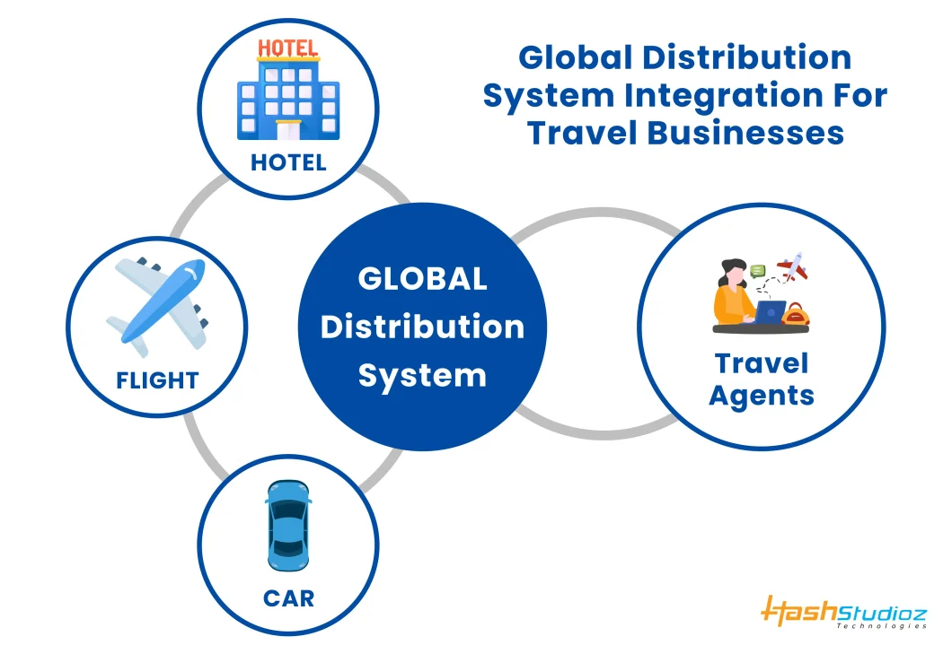



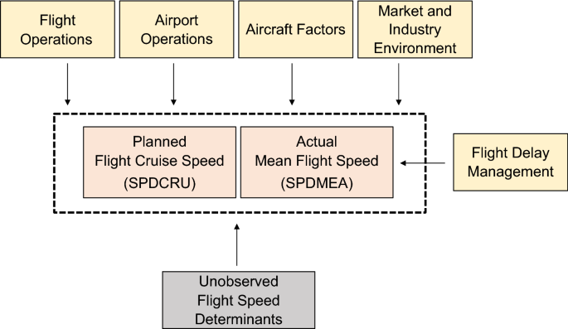

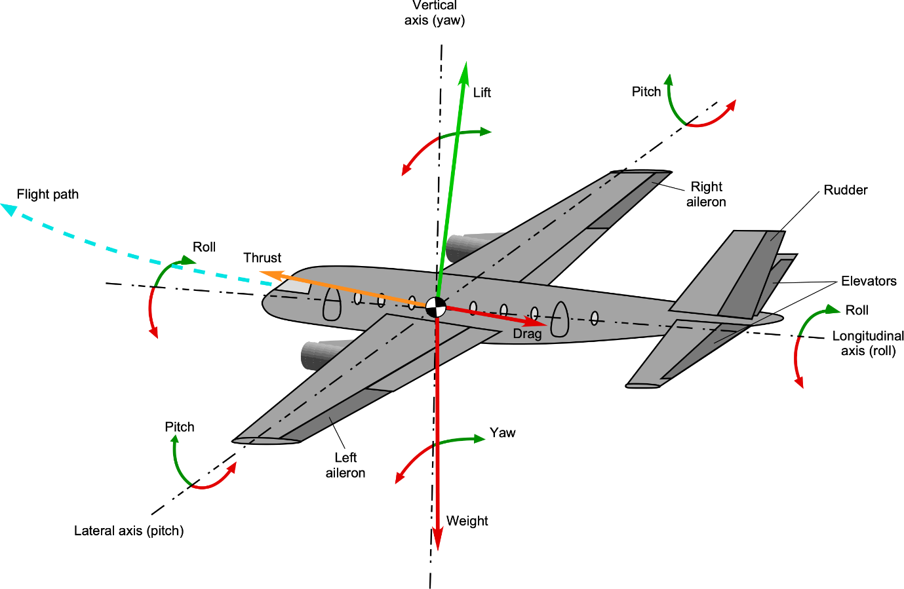

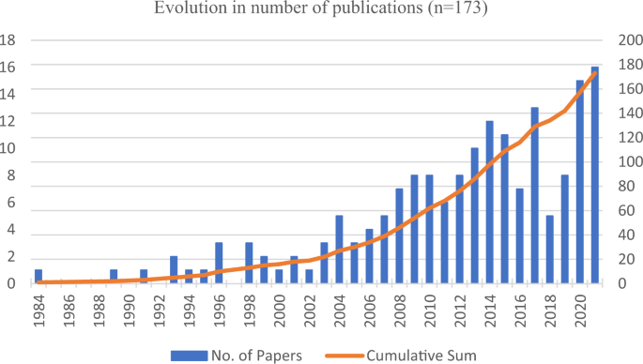

**REFERENCE:**

**Booking Reference/PNR/Record Locator:**

**Airline Reference Number:**

**Airline Website/App:**

**CONCLUSION:**

**Flight search and reservation algorithms are the backbone of modern travel. They involve complex processes of data retrieval, normalization, query processing, pricing, and ensuring a smooth user experience. While the examples provided are simplified, real-world systems need to consider many more factors, including security, scalability, and real-time updates. As technology advances, these algorithms continue to evolve, providing travelers with more choices**